3-1 Lab Worksheet
Andree Salvo
Southern New Hampshire University
CYB 240-13711
Instructor: Brian Remson

CYB 240 Module Three Lab Worksheet

Lab: SQL Injections (SQLi)
Prompt | Response
In the lab section “Analysis of the Vulnerability,” Step 20, insert your name at the command line below the output and include it in your screenshot. | 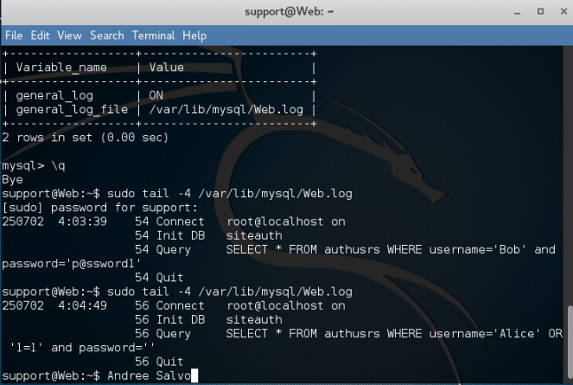
In the lab, we demonstrated the dangers of unsecured input and how it can lead to SQLi. The lab also demonstrated how escaping can be used to mitigate an SQLi password bypass attack. Explain the steps of escaping and why it was successful in mitigating the SQL injection attack. | Escaping worked because it stopped the input from messing with the SQL query. It treated the special characters like normal text so that the injection couldn’t go through.

Lab: Performing SQL Injection to Manipulate Tables in a Database
Prompt | Response
In the lab section “Stealing Data and Creating a Backdoor,” Step 7, insert your last name as the user that is created. Also use the name in Step 8. Take a screenshot after Step 8. | 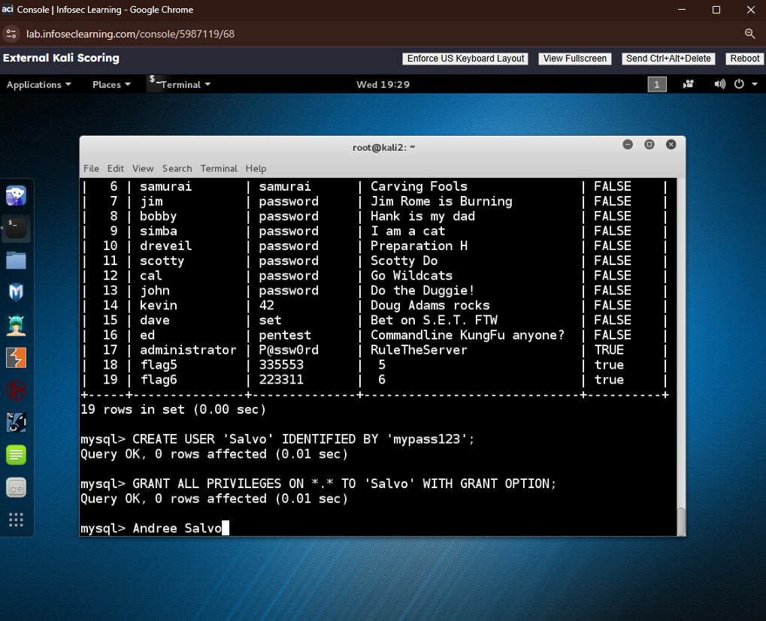
Metasploit is an open source free tool that is shipped with Kali Linux. The tool can also be added to other distributions of Linux. How can this tool be used by security analysts to help secure computer systems that they are responsible for maintaining? | Metasploit is a pen-test tool security analysts use to simulate real-world attacks on the systems they manage. It helps them identify and address any weak spots before a real attacker can exploit them. It’s a go-to tool when they need to tighten up system security.

Lab: Session Stealing (Stored XSS)
Prompt | Response
In the lab section “Alice Gets Owned,” Step 12, insert your name in the comment field and then take a screenshot of the dialog. | 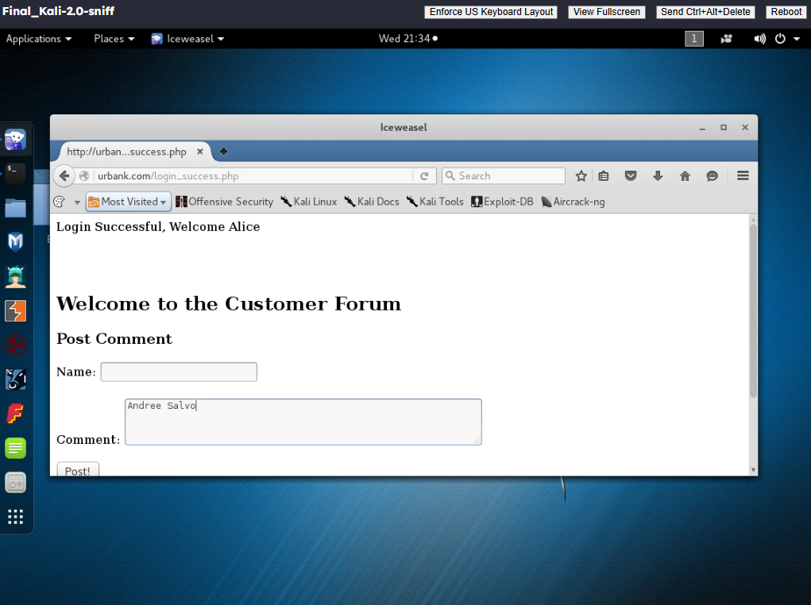
In the lab, you learn to exploit stored XSS. What steps can be taken on a form that would prevent the ability of a stored XSS to execute, and how should they be implemented? | To prevent stored XSS, validate and sanitize user input, escape output, and use a Content Security Policy (CSP).

